WE NEED YOUR HELP!!!

We are currently reading a story called The Keeping Quilt by Patricia Palocco. The story shows how every family is special and unique! As a culminating activity everyone will be participating in a CLASS QUILT SHOW on Friday October 23rd, Grandparent’s Day!! The show will start at 1:10 P.M. Every child will need to bring a quilt to share at the quilt show, by OCTOBER 19th. Your child will be asked to tell about their quilt in front of the grandparents in their homeroom. We even have a scavenger hunt prepared for our visitors to complete with their grandchild! PLEASE MAKE SURE YOUR CHILD HAS A QUILT OR SOME TYPE OF HOMEMADE (crocheted or knitted) ARTICLE THEY WOULD LIKE TO SHARE.

Thank you for your help!

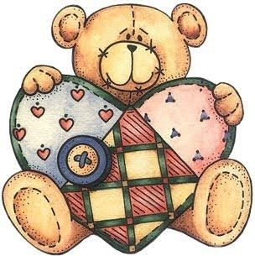
Mrs. Sorenson and Mrs. Hellige
Detach and return attached to the Quilt.

_______________________________________________ brought this quilt.

This quilt is from the _________________________________________________ family.

It was made by ______________________________________________.

It is ___________________ years old.

This quilt is the ____________________________ pattern

